Assignment 7

**Program 1**

/*"Write a program that reads a text file and creates another file that is identical except that every character is in upper case." */

#include<iostream>

#include<conio.h>

#include<stdlib.h>

#include<ctype.h>

#include<fstream>

using namespace std;

int main( )

{

ofstream outfile;

ifstream infile;

char fname1[10],fname2[20];

char ch,uch;

system("cls");

cout<<"Enter a file name to be copied ";

cin>> fname1;

cout<<"Enter new file name";

cin>>fname2;

infile.open(fname1);

if( infile.fail( ) )

{

cerr<< " No such a file Exit ";

exit(1);

}

outfile.open( fname2);

if(outfile.fail( ))

{

cerr<<"Unable to create a file";

exit(1);

}

while( !infile.eof( ) )

{

ch = (char) infile.get( );

uch = tolower(ch);

cout<<"done";

outfile.put(uch);

}

infile.close( );

outfile.close( );

return 0;

}

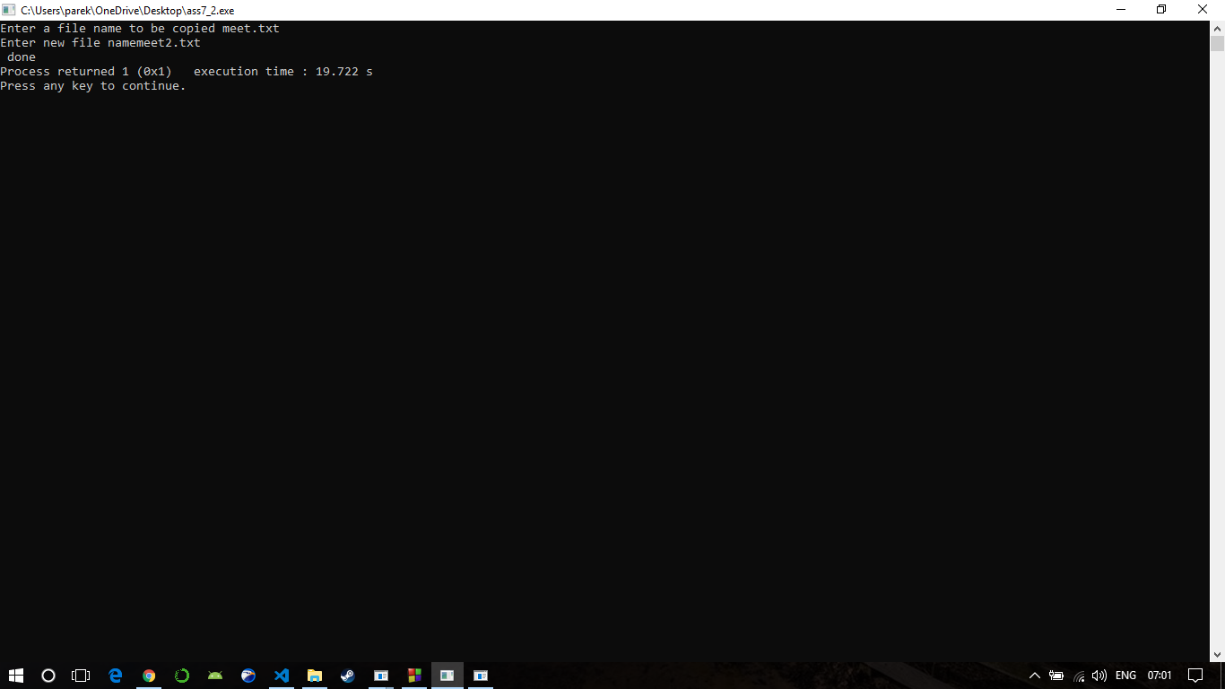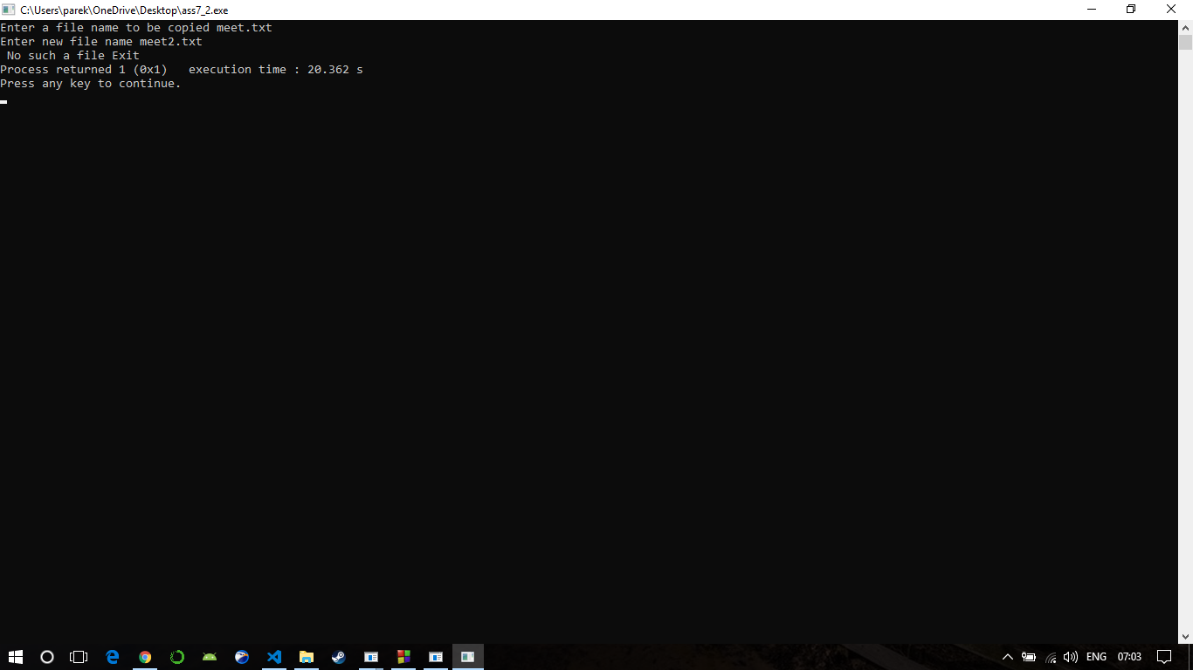

**Program 2**

/*”Write a program that reads a text file and creates another text file that is identical except that every letter must be converted to lower case irrespective of its original case (e.g ‘a’ or ‘A’ will become ’a’).”*/

#include<iostream>

#include<conio.h>

#include<stdlib.h>

#include<ctype.h>

#include<fstream>

using namespace std;

int main( )

{

ofstream outfile;

ifstream infile;

char fname1[10],fname2[20];

char ch,uch;

system("cls");

cout<<"Enter a file name to be copied ";

cin>> fname1;

cout<<"Enter new file name";

cin>>fname2;

infile.open(fname1);

if( infile.fail( ) )

{

cerr<< " No such a file Exit ";

exit(1);

}

outfile.open( fname2);

if(outfile.fail( ))

{

cerr<<"Unable to create a file";

exit(1);

}

while( !infile.eof( ) )

{

ch = (char) infile.get( );

uch = tolower(ch);

cout<<"done";

outfile.put(uch);

}

infile.close( );

outfile.close( );

return 0;

}



**Program 3**

/*” Write a program which uses command line argument to copy the contents of a file A.txt into another file B.txt by reversing case of the characters. E.g. File A.txt: aBCd File B.txt: AbcD.”*/

#include<iostream>

#include<fstream>

#include<ctype.h>

#include<conio.h>

using namespace std;

int main()

{

ifstream fin;

fin.open("meet1.txt");

ofstream fout;

fout.open("meet2.txt");

char ch;

while(!fin.eof())

{

fin.get(ch);

if(ch>=97 && ch<=122)

{

ch=toupper(ch);

}

else if(ch>=65 && ch<=90)

{

ch=tolower(ch);

}

fout<<ch;

}

cout<<"\n Data has been copied";

fin.close();

fout.close();

return 0;

}



**Program 4**

/*Write a program to copy the contents of a source file student1.txt to a destination file student2.txt character by character.*/

#include<iostream>

#include<conio.h>

#include<fstream>

#include<stdio.h>

#include<stdlib.h>

using namespace std;

int main()

{

system("cls");

ifstream fs;

ofstream ft;

char ch, fname1[20], fname2[20];

cout<<"Enter source file name with extension (like files.txt) : ";

gets(fname1);

fs.open(fname1);

if(!fs)

{

cout<<"Error in opening source file..!!";

exit(1);

}

cout<<"Enter target file name with extension (like filet.txt) : ";

gets(fname2);

ft.open(fname2);

if(!ft)

{

cout<<"Error in opening target file..!!";

fs.close();

exit(2);

}

while(fs.eof()==0)

{

fs>>ch;

ft<<ch;

}

cout<<"File copied successfully..!!";

fs.close();

ft.close();

return 0;

}

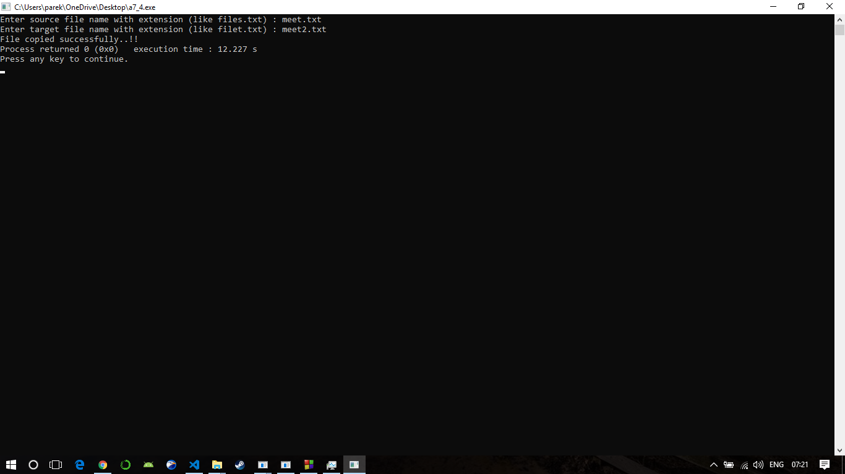

**Program 5**

/*"A file contains a list of phone numbers in the following form John 23406 Ahmed 56789 ….. ….. The name contains only one word and the names and telephone numbers are separated by white spaces. Write a program to read the file and output the list in two columns."*/

#include<iostream>

#include<fstream>

#include<conio.h>

#include<iomanip>

using namespace std;

int main()

{

fstream file,f2;

// system("cls");

file.open("contact.txt",ios::in|ios::out);

file.seekg(0);

char ch,ch1;

int cnt=0;

file.get(ch);

while(file)

{

ch1 = ch;

file.get(ch);

if( ch == ' ' && ch1 != ' ')

{

cout<<ch1<<" ";

}

if(ch != ' ' && ch1 != ' ')

{

cout<<ch1;

}

}

file.close();

return 0;

}

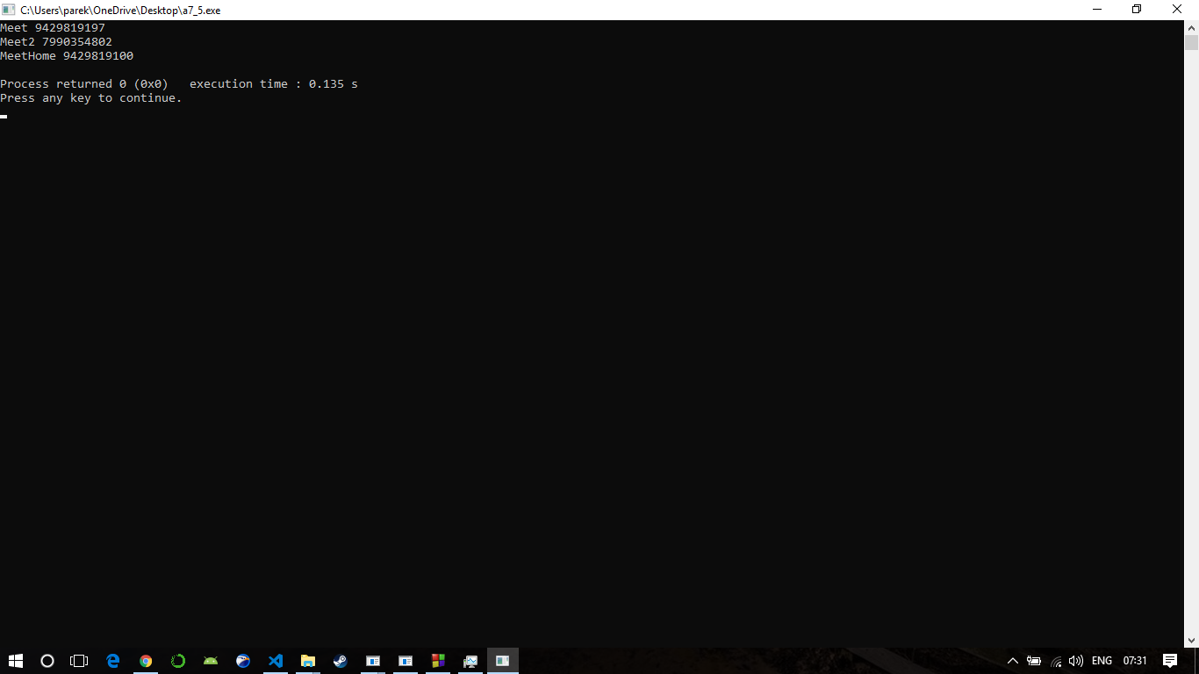

**Program 6**

/* Write a program that opens two text files for reading data. It creates a third file that contains the text of first file and then that of second file (text of second file to be appended after text of the first file, to produce the third file).*/

#include <stdio.h>

#include <stdlib.h>

#include <conio.h>

int main()

{

// Open two files to be merged

FILE *fp1 = fopen("1.txt", "r");

FILE *fp2 = fopen("2.txt", "r");

// Open file to store the result

FILE *fp3 = fopen("3.txt", "w");

char c;

if (fp1 == NULL || fp2 == NULL || fp3 == NULL)

{

puts("Could not open files");

exit(0);

}

// Copy contents of first file to 3.txt

while ((c = fgetc(fp1)) != EOF)

fputc(c, fp3);

// Copy contents of second file to 3.txt

while ((c = fgetc(fp2)) != EOF)

fputc(c, fp3);

printf("Merged 1.txt and 2.txt into 3.txt");

fclose(fp1);

fclose(fp2);

fclose(fp3);

return 0;

}

